Student work samples
(from exam trials)

2008/18228[2]

Student work samples—Stage 2 Sample Exam

The following three student work samples are responses by Year 11 students to the Stage 2 Sample Exam Section Three: Document Study, using the context Civil Rights Movement in the USA 1940s–1970s. These students were part of a class at Shenton College which trialled Civil Rights Movement in Semester Two 2007. They completed this work as part of their Semester Two exam. We thank the staff and students of Shenton College for providing this material.

NOTE: The Stage 2 Sample Exam and Marking guide have been developed for students completing Stage 2 in Year 12, however they can be adapted to Year 11 as the unit content is the same. Expectations of the sophistication of responses will be somewhat different between the different year groups.

Questions (A), (B), (C) and (E) are a familiar style of question recognisable from the current TEE exam. Question (D) is a question more directly related to the Historical thinking and methodology section of the unit content. The three papers show a range of responses to this question. One answer shows a high level of sophistication, particularly as there was only one semester of engagement with the new course content.

STUDENT A

SECTION A: DOCUMENT STUDY
This section has ONE (1) question made up of FIVE (5) parts, Attempt ALL parts. Write your answers in the spaces provided. Please write your answer using pen, not pencil.
The marks allocation for this section is 25 marks.
Allow approximately 45 minutes for this section.

- Describe the message of Source 1.
[3 marks]

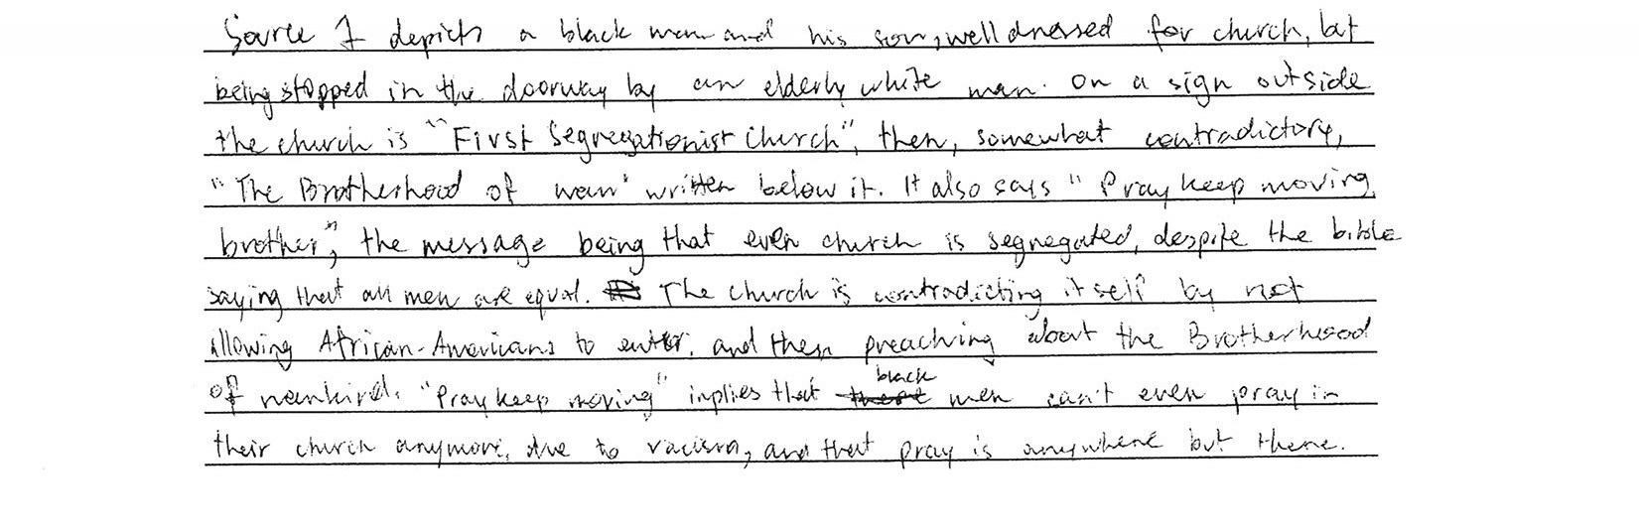

- Compare and contrast the messages of Source 1 and Source 2.
[5 marks]

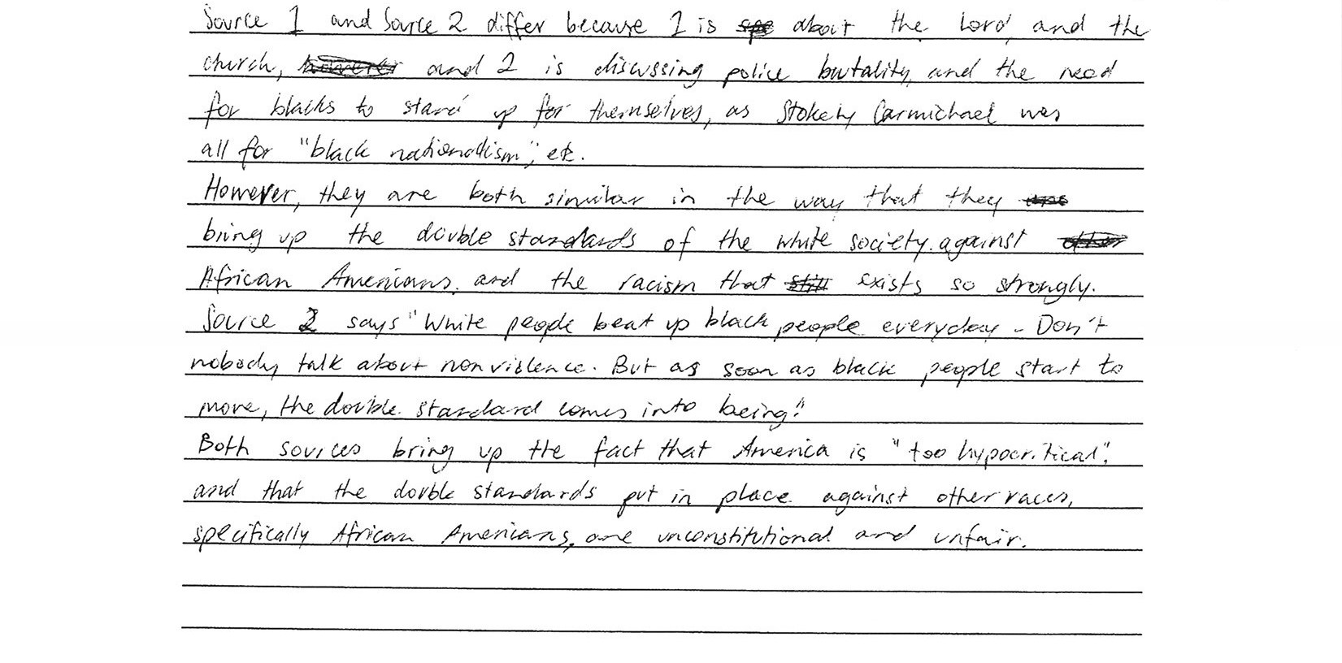

- What is the context of Source 3—that is, the people, actions or events shown?
[5 marks]

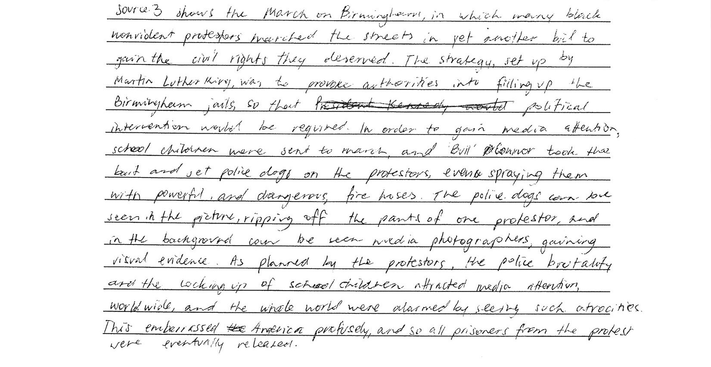
- How useful are these three sources for an historian investigating the period? Your answer may include comments on reliability, relevance, bias and purpose.
[6 marks]

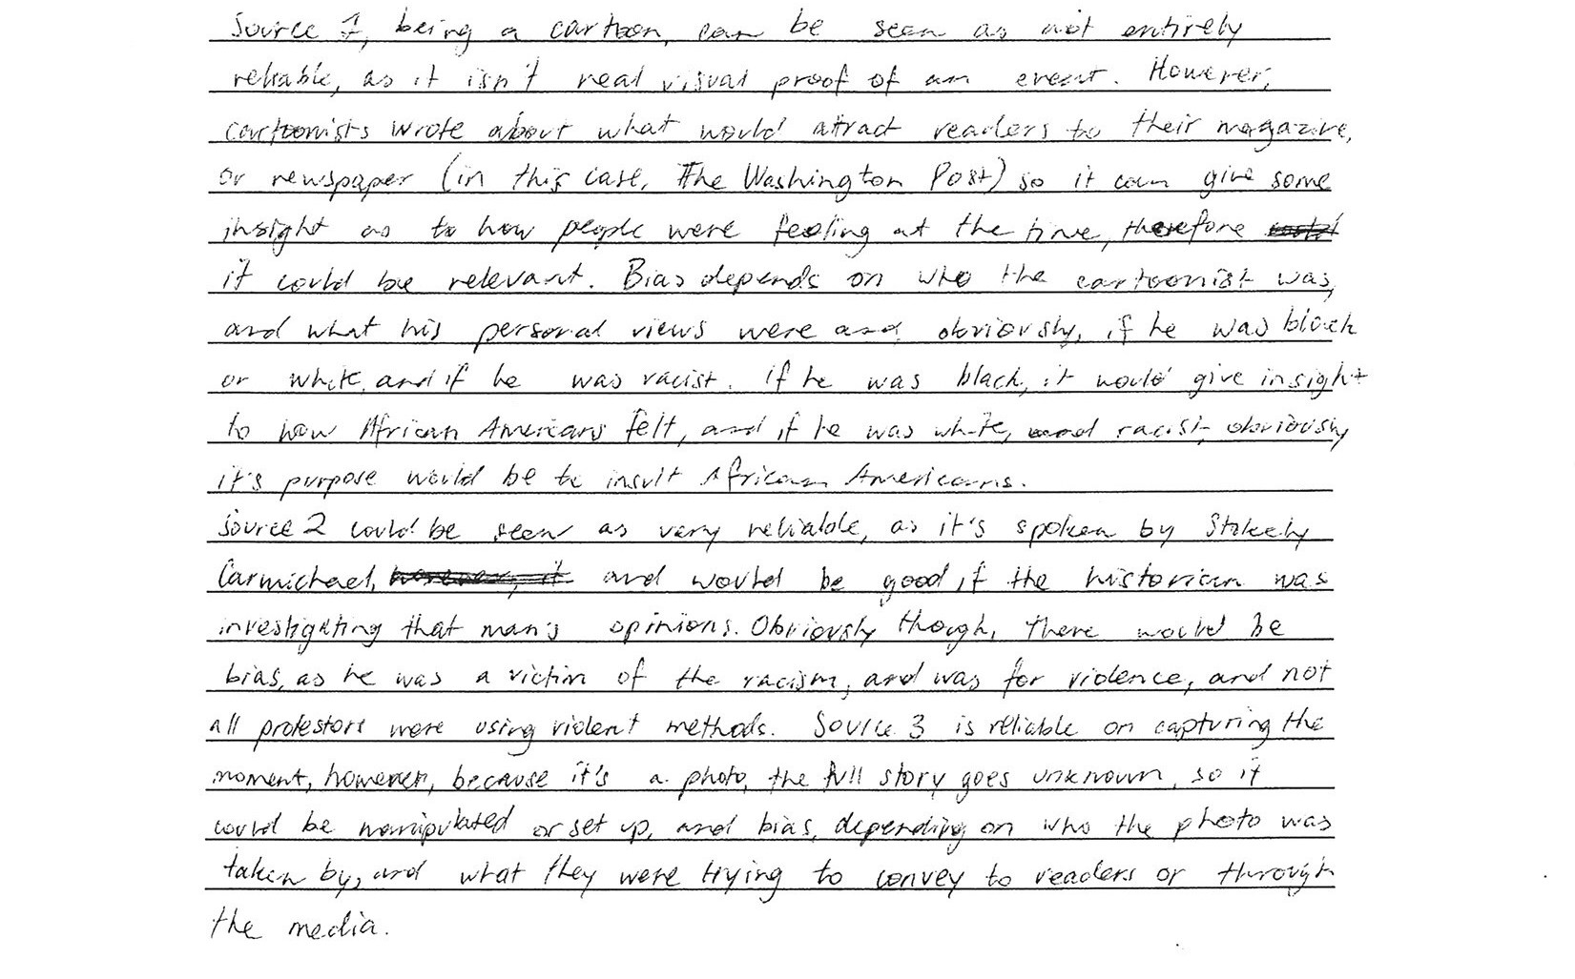
- To what extent do the three sources represent the major underlying trends and movements of the area of study?
[6 marks]
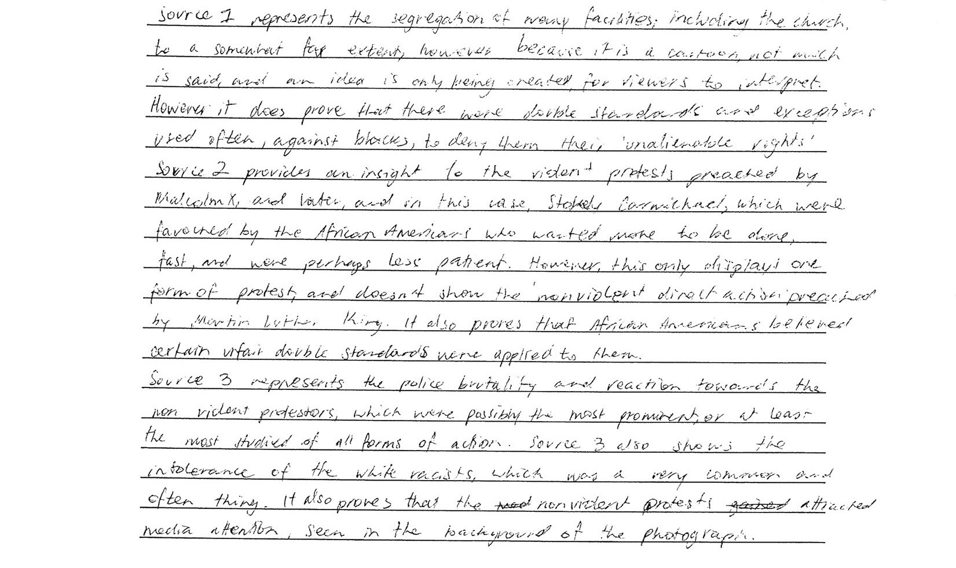

STUDENT B

SECTION A: DOCUMENT STUDY
This section has ONE (1) question made up of FIVE (5) parts. Attempt ALL parts. Write your answers in the spaces provided. Please write your answer using pen, not pencil.
The marks allocation for this section is 25 marks.
Allow approximately 45 minutes for this section.

- Describe the message of Source 1.
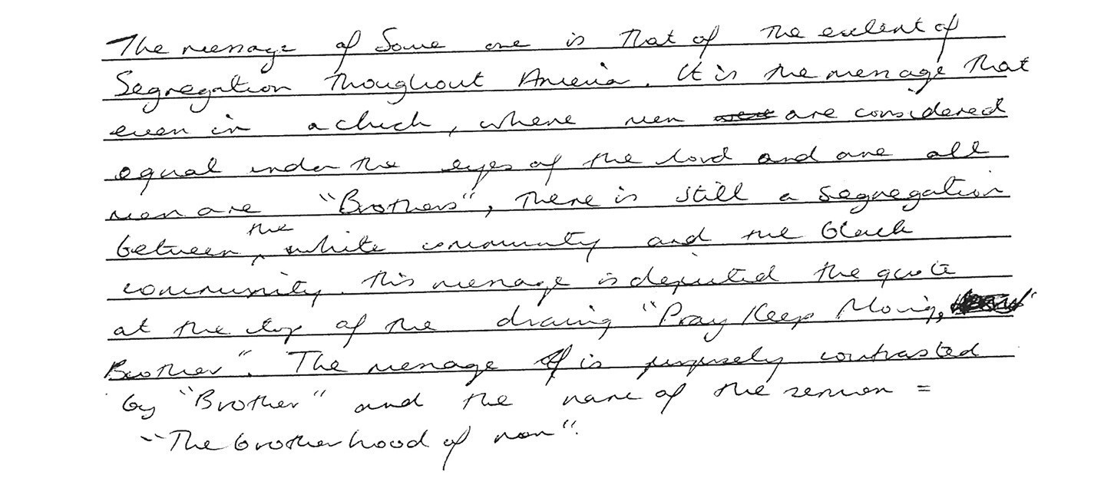
[3 marks]

- Compare and contrast the message of Source 1 and Source 2.
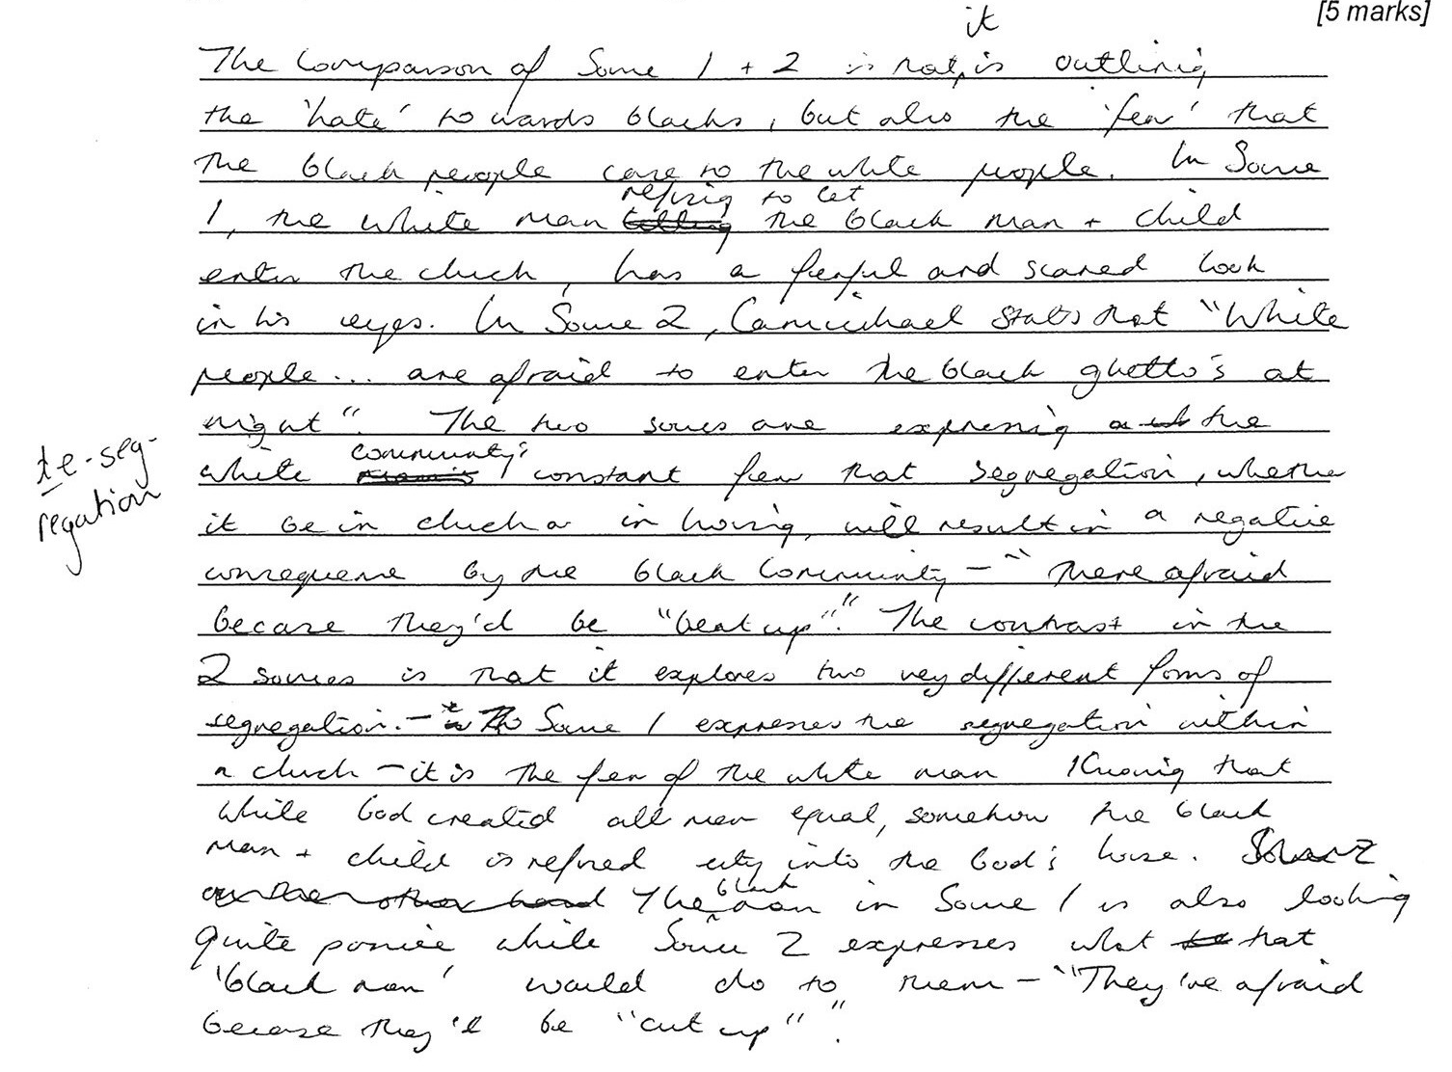
(C) What is the context of Source 3—that is, the people, actions or events shown?
[5 marks]

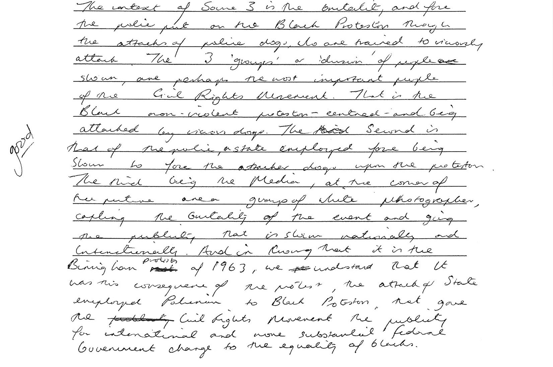
(D) How useful are these three sources for an historian investigating the period? Your answer may include comments on reliability, relevance, bias and purpose.
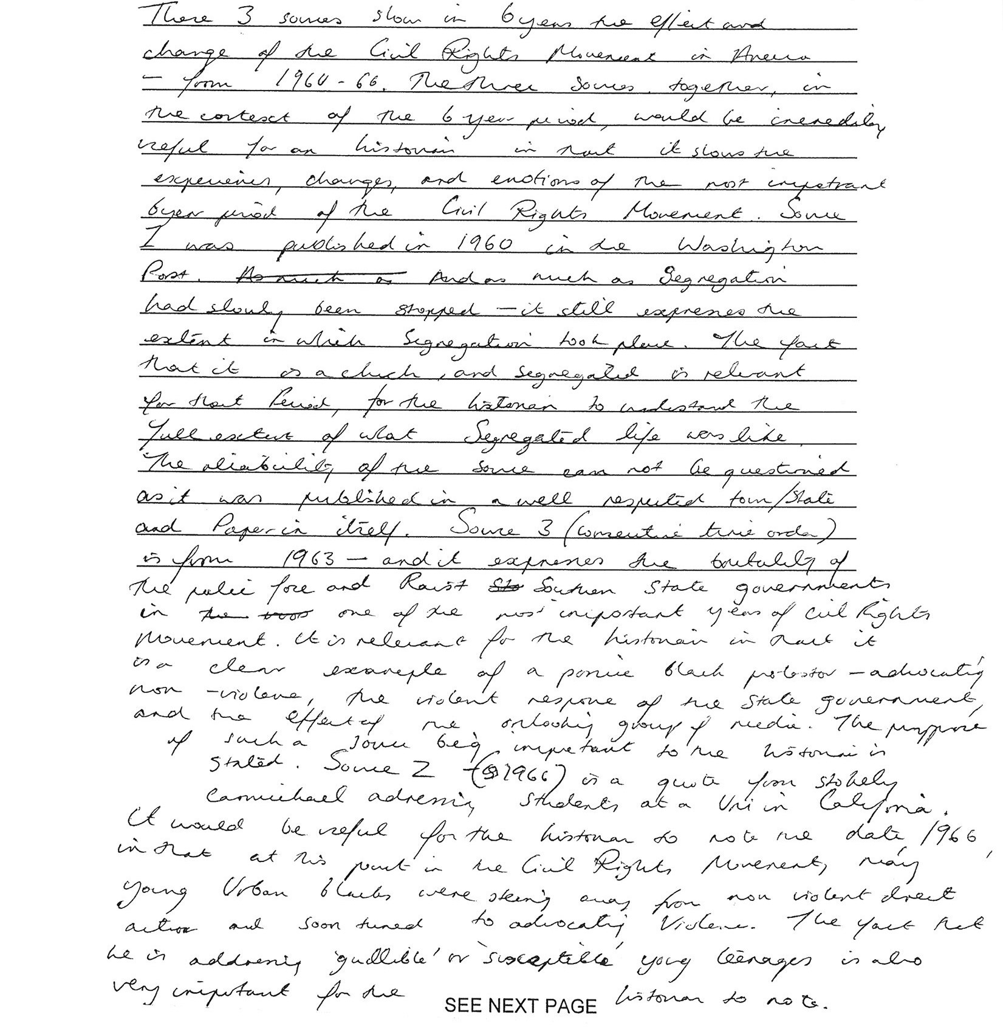
[6 marks]
(E) To what extent do the three sources represent the major underlying trends and movements of the area of study?
[6 marks]

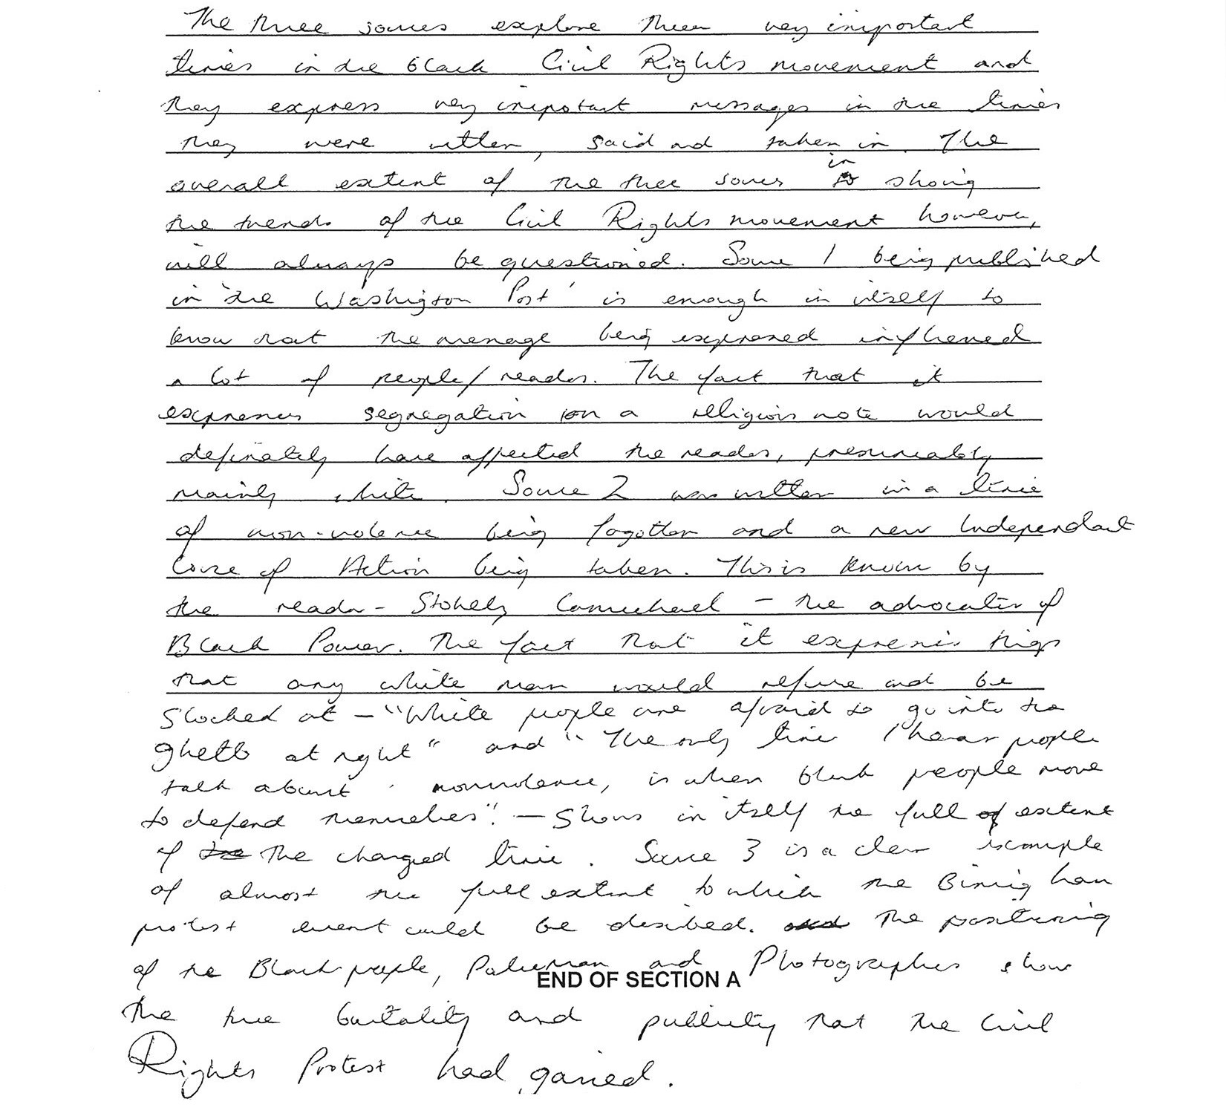

STUDENT C

SECTION A: DOCUMENT STUDY
This section has ONE (1) question made up of FIVE (5) parts. Attempt ALL parts. Write your answers in the spaces provided. Please write your answer using pen, not pencil.
The marks allocation for this section is 25 marks.
Allow approximately 45 minutes for this section.

(A) Describe the message of Source 1.
[3 marks]

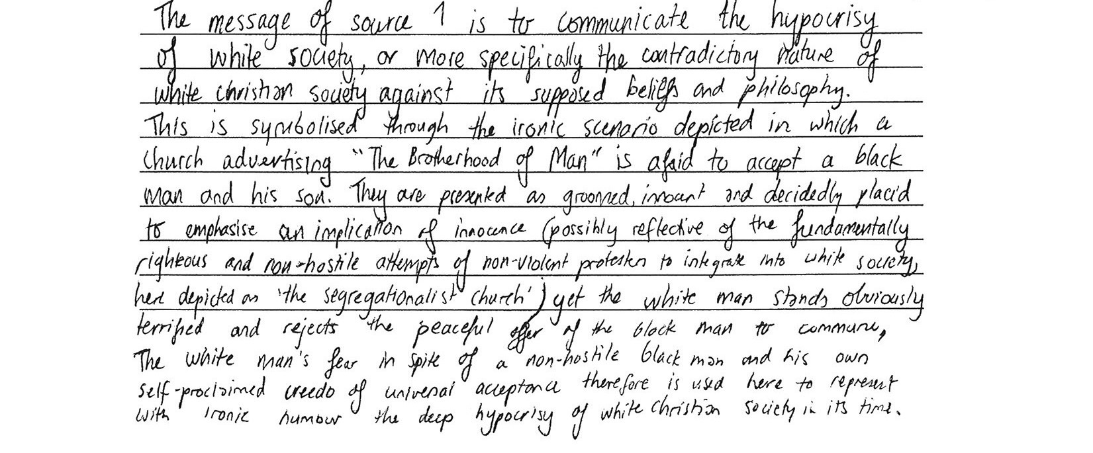
(B) Compare and contrast the messages of Source I and Source 2.
[5 marks]

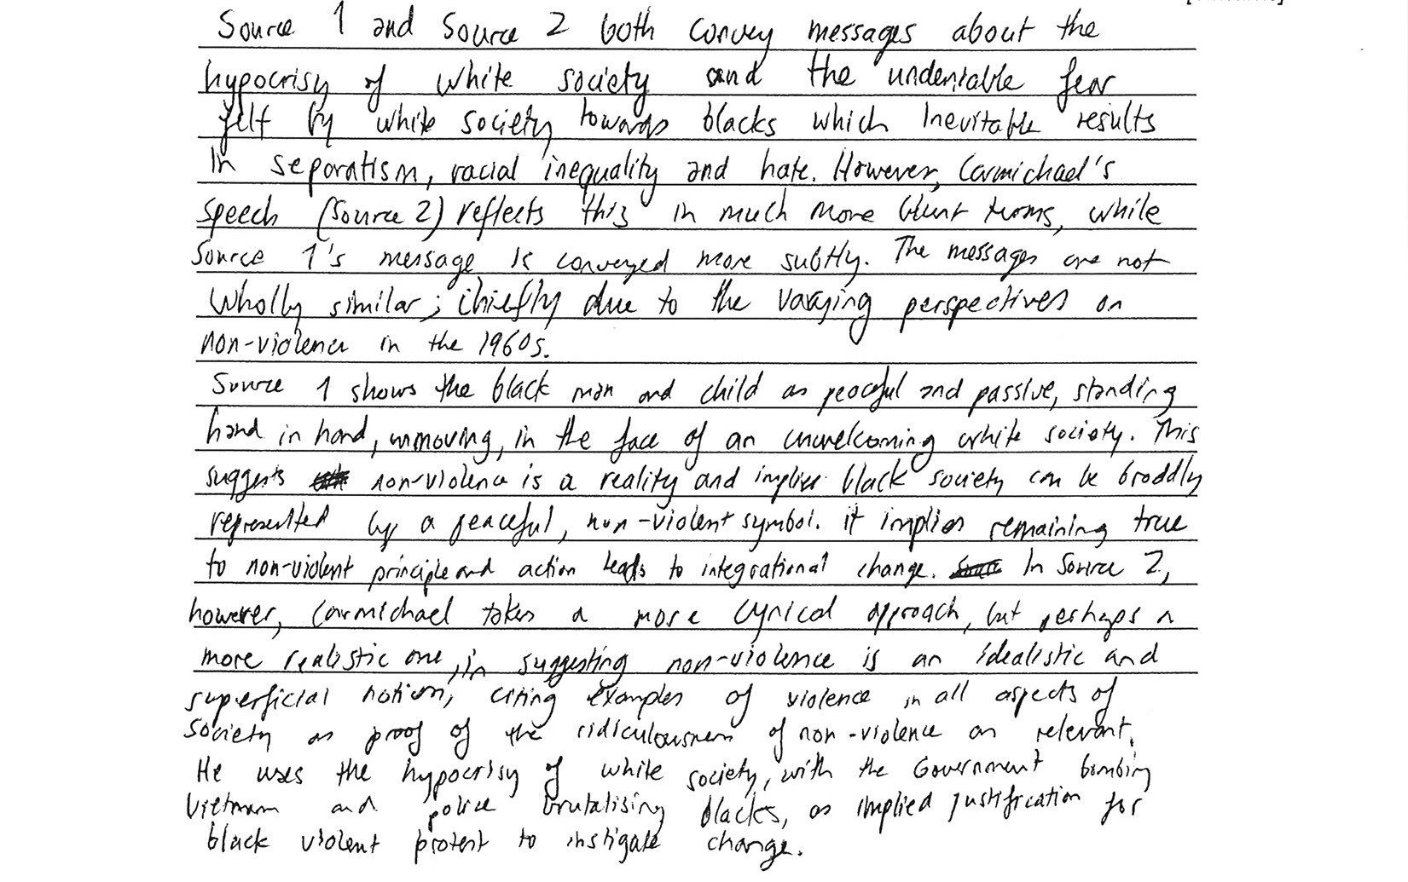
(C) What is the context of Source 3—that is, the people, actions or events shown?
[5 marks]

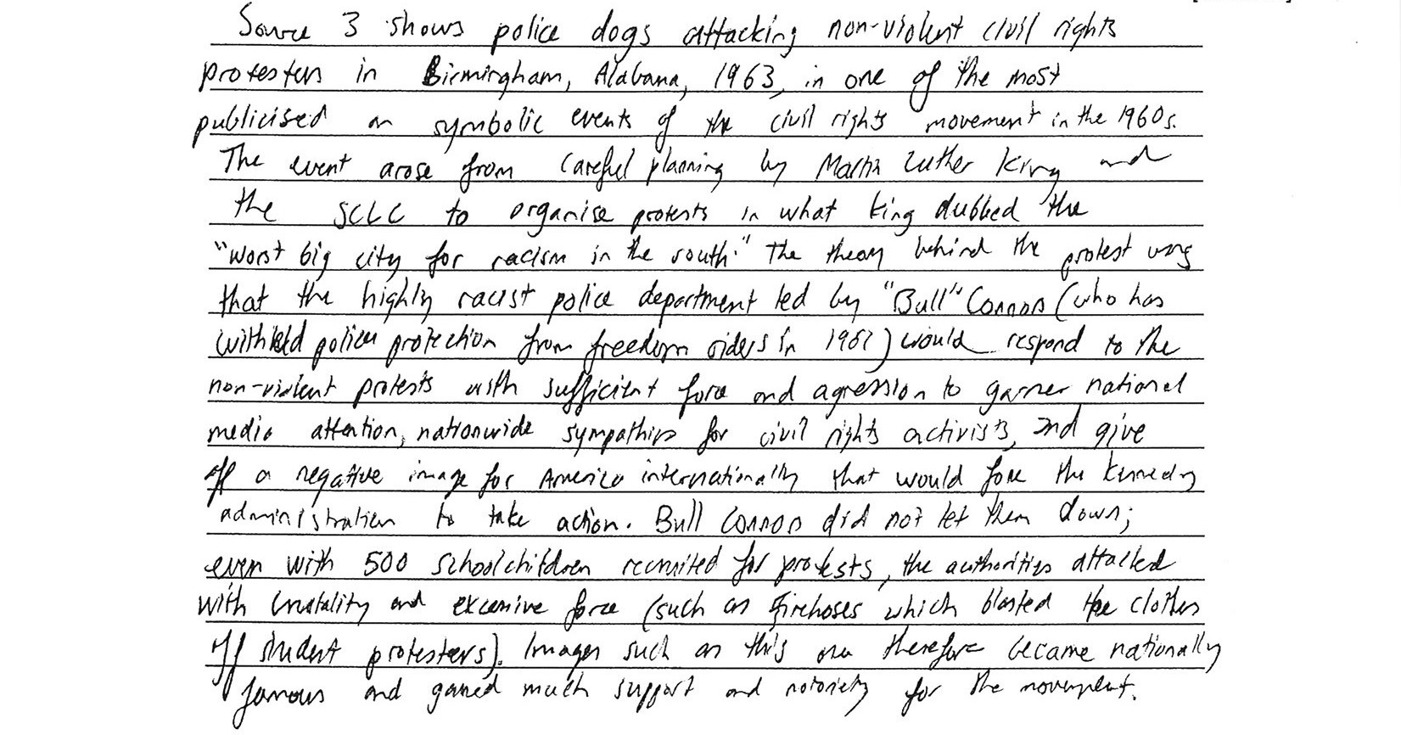

(D) How useful are these three sources for an historian investigating the period? Your answer may include comments on reliability, relevance, bias and purpose.
[6 marks]

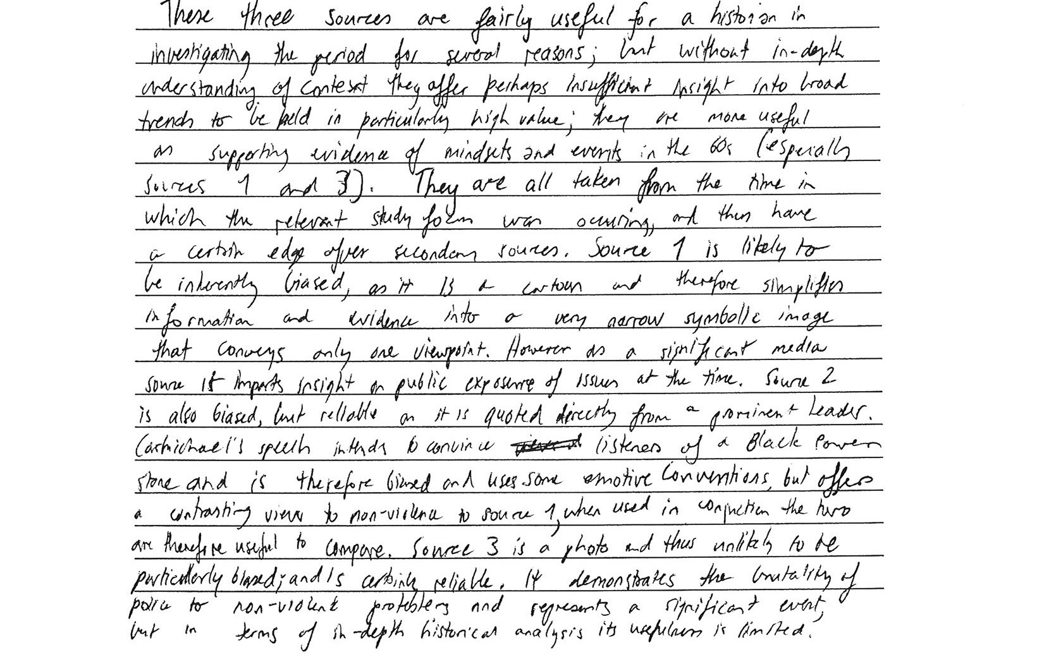

(E) To what extent do the three sources represent the major underlying trends and movements of the area of study?
[6 marks]

